Based on the general browsing of the flexible search project, after browsing the modules of the project, we have a certain understanding of the project. The project is built for the cloud though Elastic search is a distributed restful search engine. The context view of the report has been preliminarily divided and some necessary source code is read at the same time. There are many more options to perform search, after all, it's a search product no. All the familiar Lucene queries are available through the JSON query language, or through the query parser. Through collecting the history of the project and the use manual, we can understand the prototype of the project, the subsequent improvement and improvement, and the products currently promoted by the business. It is convenient for us to understand the project in depth and lay the foundation for the follow-up analysis view. Generally speaking, Elasticsearch is a highly available and distributed search engine. Each index is broken down into shards, and each shard can have one or more replicas.  This resulted in a context view, of which the general overview is discussed here. The following image shows the majority of these entities.

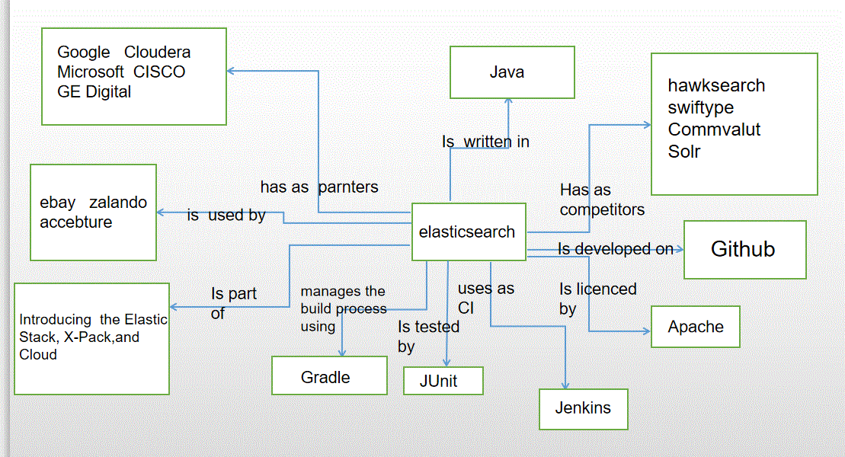

When analyzing its application scenarios, we must understand the original intention, project positioning, group-oriented, through browsing the project structure and related instructions, as a search engine, the project better achieves fuzzy processing and recognition and high response analysis. In addition, in the understanding of its history, the division of labor and integration of participants are understood, and the function of the project is roughly divided, which is a module, which is integrated with a certain analysis.

The system provides users with the corresponding permission to search for a large number of information in the environment and specific target information. The system relies on the information source and data set in the environment as the source of data collection and analysis, and feeds back the processing results to the environment itself. Users can realize the cognition of the environment ordering through the system, and can efficiently and quickly realize the ordering and targeted analysis for a large number of information that needs to be distinguished. As the graph shows as follows, it describes the relation between system and environment.

Elasticsearch can use the commonly used log formats of transmission, analysis, storage and analysis to store the received data, classify them at the same time and load them into corresponding warehouses. Depending on the massive information sources in the environment, the system can continuously identify, modify, improve and re identify the process, and constantly correct the powerful self-function. Through the system, users can interact with the environment in a regular way, avoiding that in a complex environment, users can not achieve valuable gains because of the lack of computing and analysis capabilities. Elastic search encourages you to explore and make use of data, not because it is too difficult to query data, so that they rot in the data warehouse. Through the system, the data can be separated from the characteristics of the original data element, and change the characteristics of the independent unit. It can be used as a node in the massive data set to connect and transmit data values. When analyzing data, it can also rely on each other to realize the value beyond its own data. Abundant information is just a bunch of disordered digital symbol strings when it can not be analyzed and used reasonably. Using reasonable search tools, we can accurately obtain meaningful data values, which will bring great convenience to other subsequent uses.

In the information age, a large number of information flows into each data warehouse. How to search for a specific target conveniently, the system emerges as the times require. Relying on the original starting point, it completely presents the characteristics of demand and satisfaction. Using the interaction between the system and the environment, the user indirectly realizes the interaction with the environment through the media, and realizes the function of the search system.

Here is a summary.

1. The purpose of data fragmentation is to improve the capacity of the data that can be processed and to expand it horizontally. The purpose of data fragmentation is to improve the stability and concurrency of the cluster.

2.Copy is multiplication, the more consumption, the more insurance. Sharding is division. The more shards, the less and more scattered the single shard data.

3. The more copies, the higher the availability of the cluster. However, since each partition is equivalent to an index file of Lucene, it will occupy a certain file handle, memory and CPU.